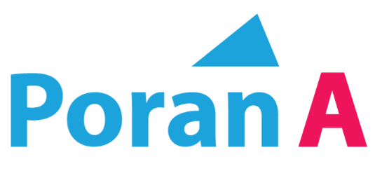

www.poran-a.com
Subscribe YouTube channel: Poran-A
Fashion Graphic Course will boost your career in RMG industries lifetime
Poran Sir
Fashion Graphic
With Adobe Illustrator

Overview
A Fashion Graphic Course can significantly boost your career in the Ready-Made Garments (RMG) industry, especially if you're aiming to work in design, product development, or merchandising.
Here’s how it can benefit you long-term:
3. Better Career Opportunities
With graphic expertise, you can work as:
A. Fashion Designer. B. Textile Designer. C. Technical Designer.
D. Product Developer. E. Merchandiser. F. Print Designer.
G. Freelance designer.
4. Higher Salary Potential
Graphic-skilled professionals are valued more in buying houses and large factories, especially those working with international brands.
5. Long-Term Career Growth
The RMG industry in countries like Bangladesh continues to expand globally. Skilled graphic designers are always in demand for:
Print development Embellishment design Trend forecasting Brand identity creation
6. Freelancing & International Work
With strong graphic skills, you can also:
Work remotely Freelancing Sell design assets online

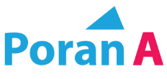
Course: Fashion Graphic with Illustrator
Mentor: Poran Sir
Class: 02 & 03
Topics: Software Introduction and Basic Navigation
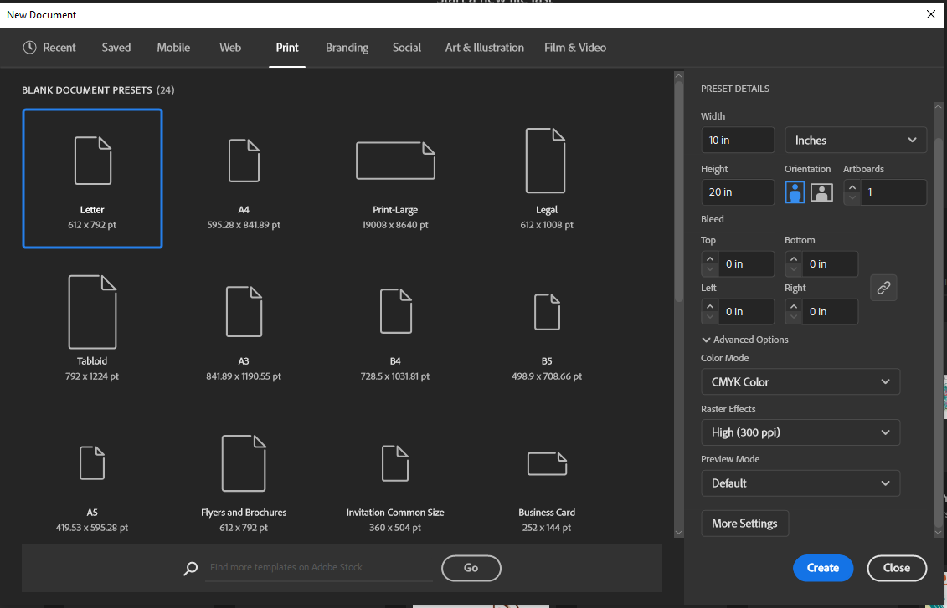
- Open Software
- Create New Document
Size 2000 X 2500 Pixel

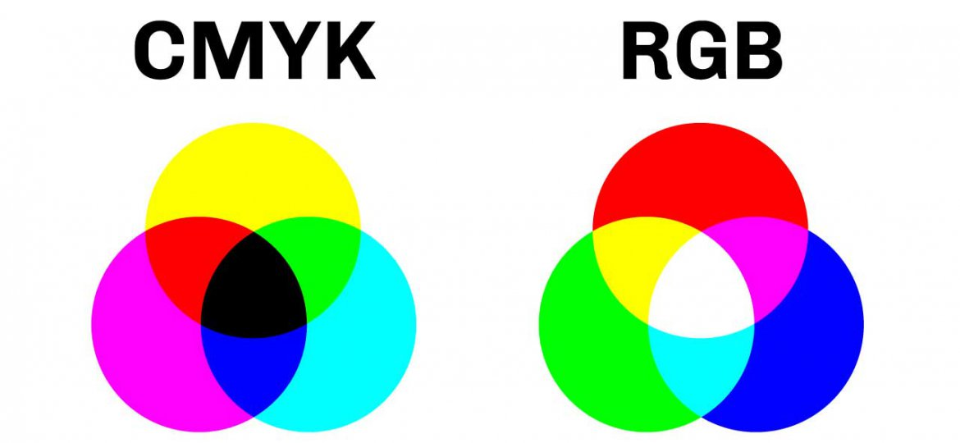
- What is COLOR MOOD?
CMYK for Press Printing
RGB for Website or Digital Midea

- Workspace Setup
Go to Window to workspace to essential classic.
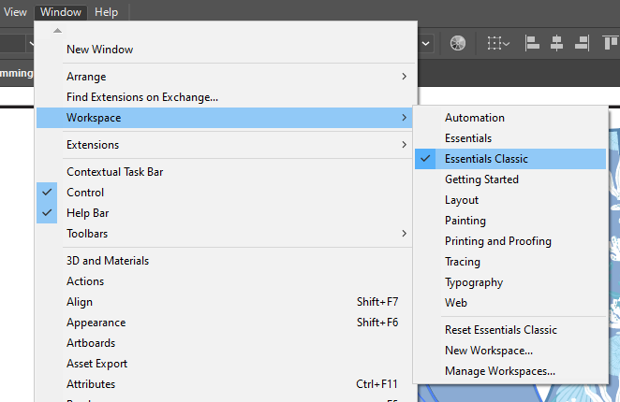
Check out all this workspace
- For Reset workspace

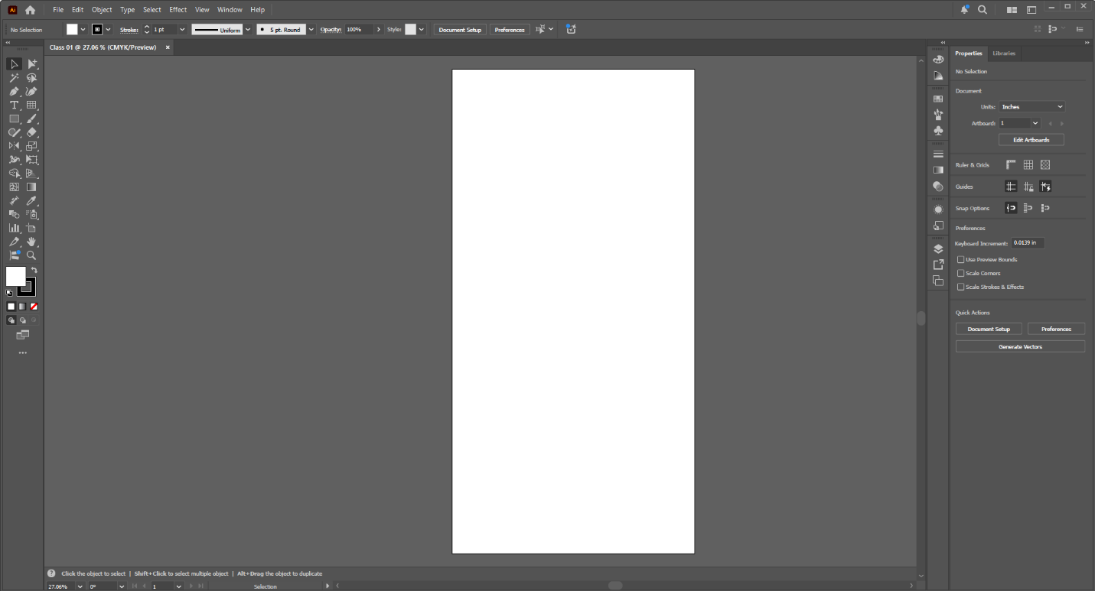
- ARTBORD Details
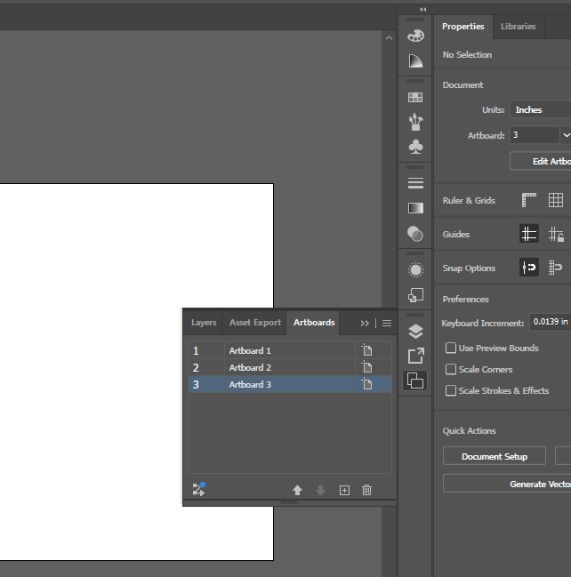
Create, Delete, change Size

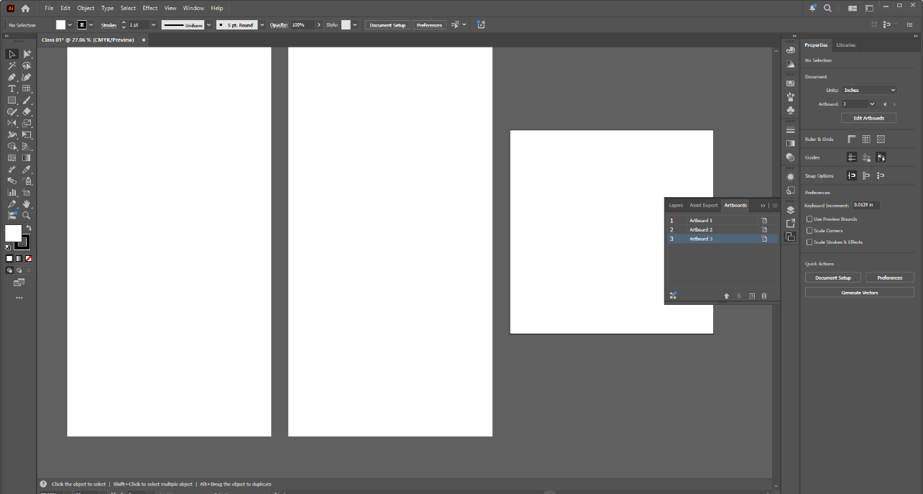
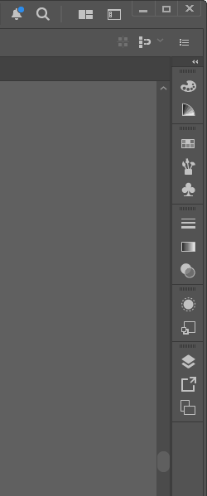
- Plate Description
Show hide delete and reset.
Plate comes from window

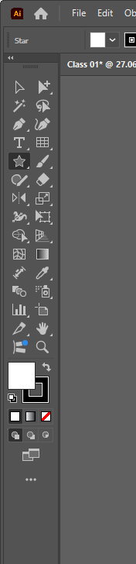
- Toolbar
Show-hide
Placed out
Move
Close
Reset

And Show from window to tools

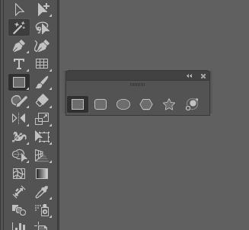
K. Shape Tools
To Draw shape, select any shape tools, click and drag

Chage shape character
Peress arow key before clicking out the mouse.

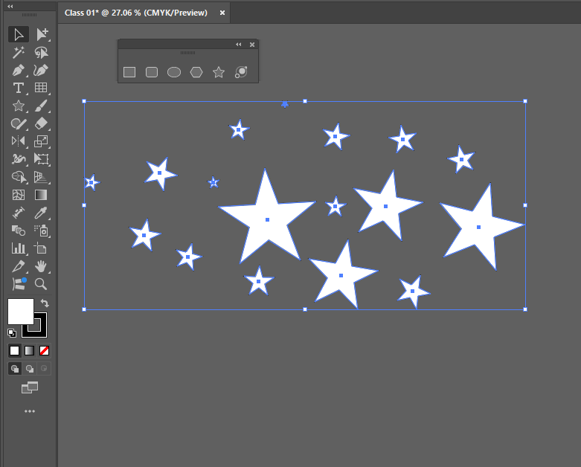
L. Selection Tools.
For Select objects, move and delete

For Multi Selection
Press Shift Key and select desire motif.
Select and Deselect
Press Shift Key and click selected object

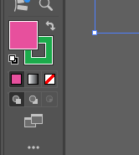
M. COLOR BOX
Fill Color
Stock color

To change the color
Select objects and Pick color from color plate
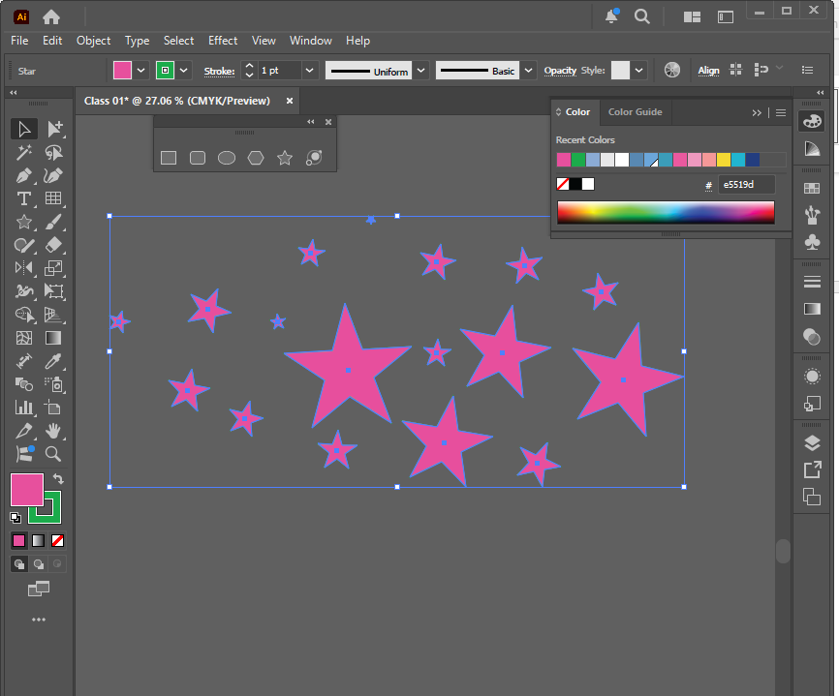
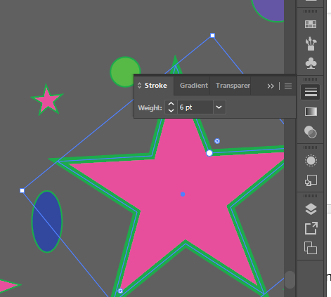
N. Strock or Border line
To change the border line
Select objects and change from stroke option.

Select objects and change from stroke option.
O. ZOOM IN and OUT
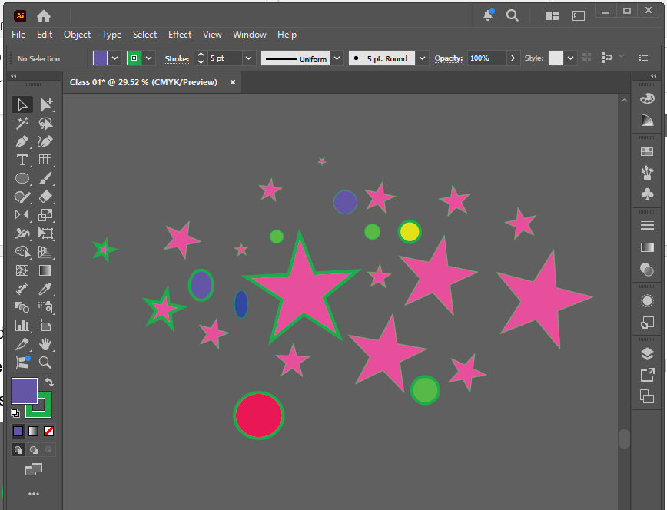
Press Ctrl+ Spacebar and click and drag mouse 45` angle.
P. Over Zoom fixed
Ctrl+0

Q. Objects bring front and back
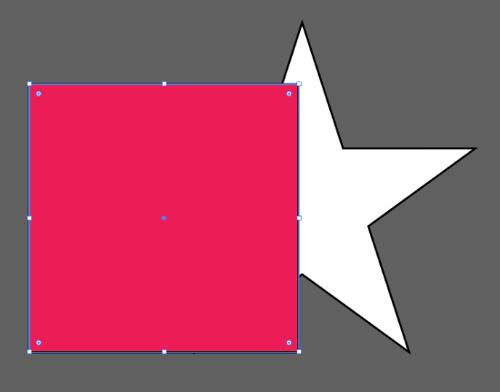
Select object arrange overlapping
Bring front and back
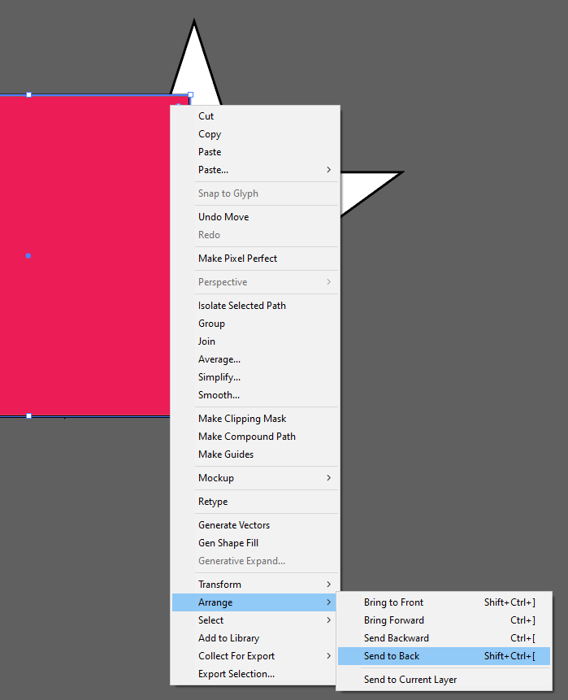

R. Undo and Redo Ctrl + Z and Ctrl +shift + Z
S. Move Artboard > Press spacebar, click mouse and drag

Thanks
You are Successfully Done

Follow Us
(14) Facebook
https://www.youtube.com/@Poran-A

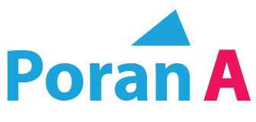

Road-03, House-54, Lift-03
Sector-12, Uttara, Dhaka

