

www.poran-a.com
Subscribe YouTube channel: Poran-A
Fashion Graphic Course will boost your career in RMG industries lifetime
Fashion Graphic Course will boost your career in RMG industries lifetime

www.poran-a.com
Subscribe YouTube channel: Poran-A
Poran Sir
Fashion Graphic
With Adobe Illustrator



Course: Fashion Graphic with Illustrator
Mentor: Poran Sir
Class: 04-05
Topics: Create all over design with Repeat

- Open Project file and move a side

- For a Repeat design
Make a 6 X 6-inch square shape
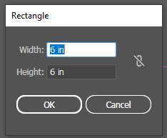
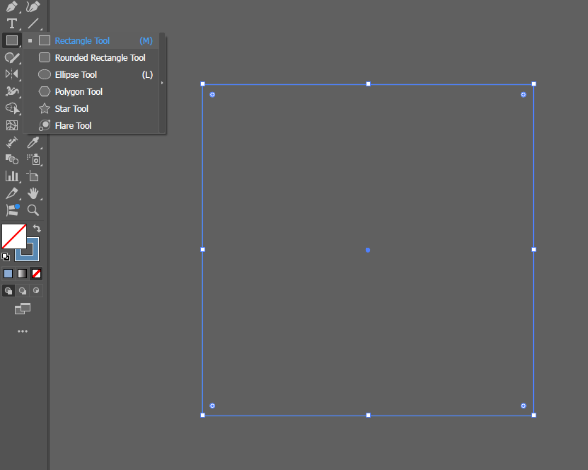

- Drow small stars
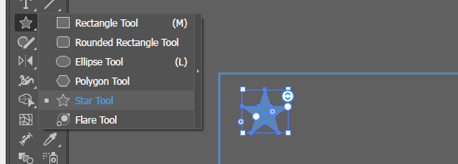

- make it Aliened Copy:

Select motif and press alt + drag motif and press shift key before clicking out for Aligned

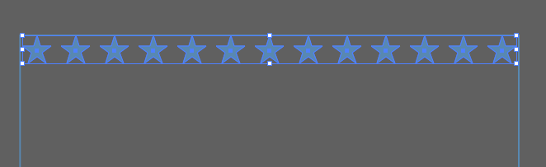
- Then press Ctrl + D For similar Repeat Copy

- Group > Select all motifs and Press Ctrl + G (For Ungroup Press Ctrl + Shift + G )

H: Effect using
Draw a Polygon Shape, Make sure the Shape is Selected
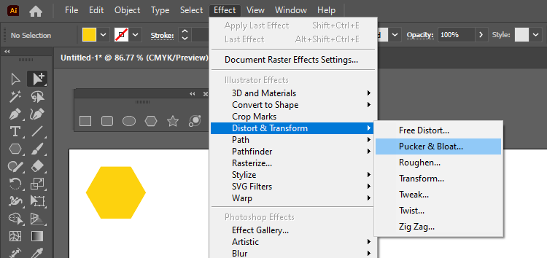
Go to Manu > Effect > Distrot & Transform > Pucker & Bloat,

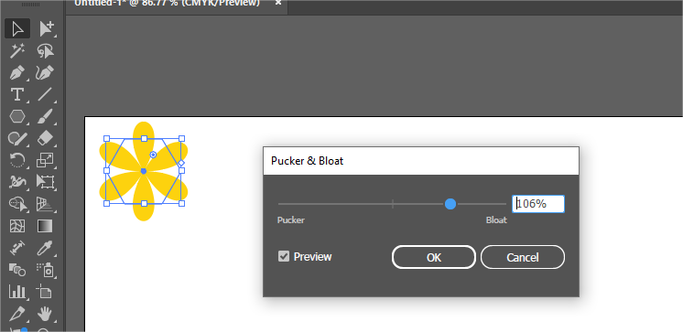
Drag slider accordingly
Expand Appearance
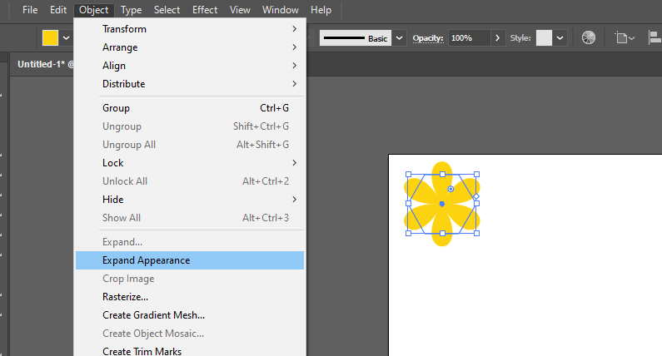
Go to Object > Expand Appearance

Make it copy and change color
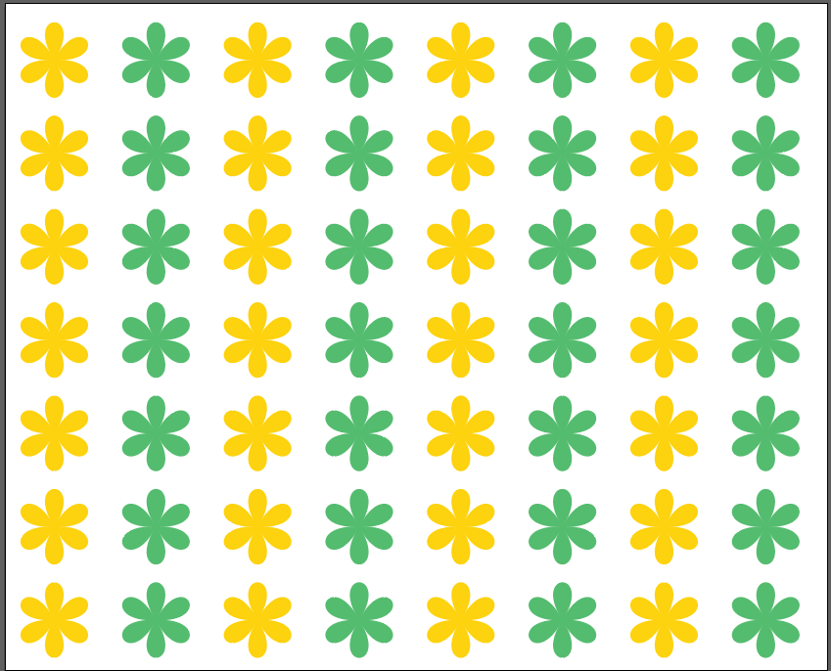
Create allover Repeat design
- Magic Want Tools Y
For Similar Color Selection
This tool use for all similar colors Replacing from the complex artwork
Click a solid color object from your artwork and change color
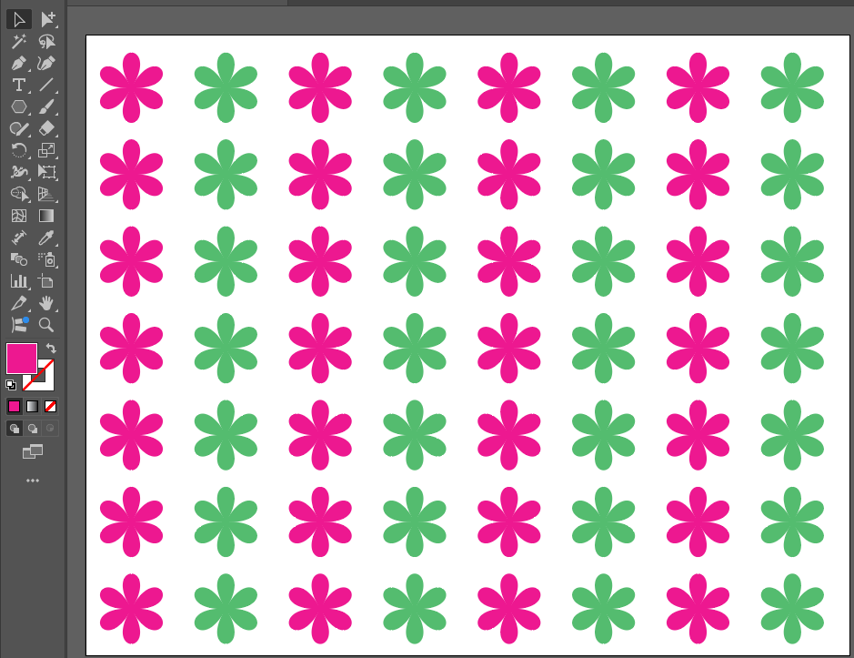
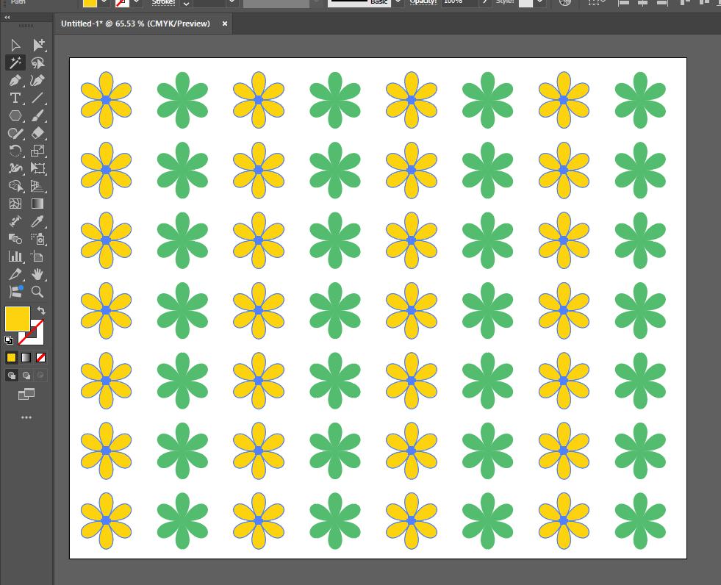
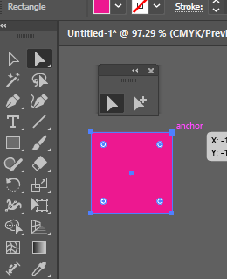
- Direct Selection Tool A
For select Anchor point.
To move pint
To delete line
To select full object
To get curve points

How you identify
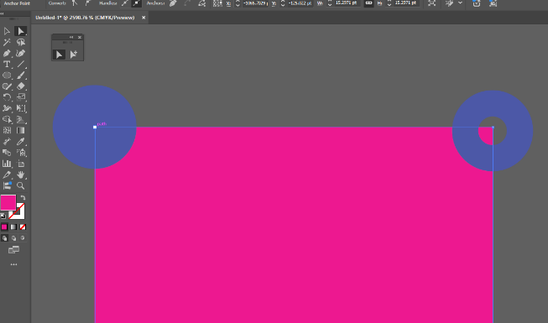
anchor point is selected.
when you click on a point that
will be like flue fill and other point
will be out fill



Create this motif By Selection tool
Copy square shape Ctrl + C
Past in front Ctrl + F
Change the front motif color
Curve the front motif by selection tools
Then Create Repeat Design
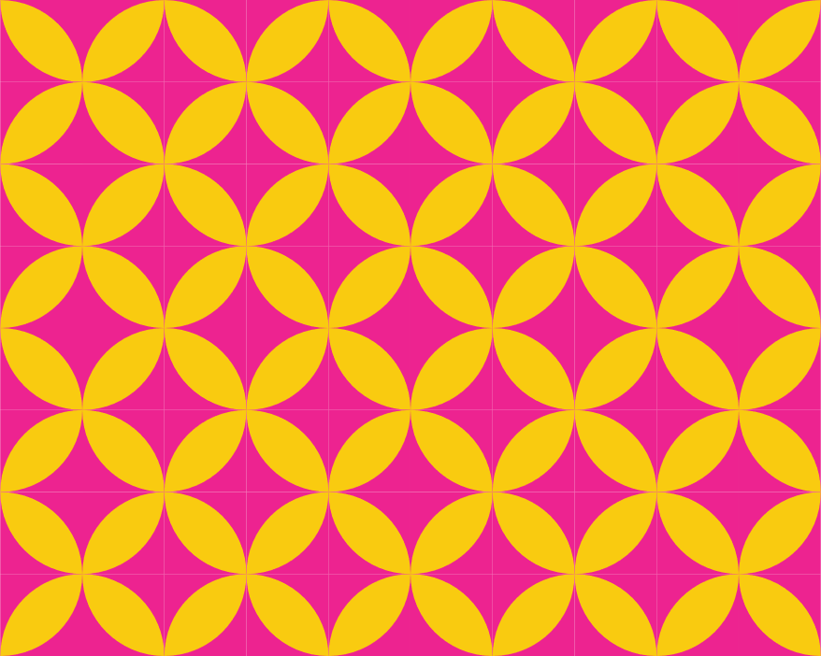


Create Swatches
- Align your motif in front of background shape,
make sure that will be proper repeating

- Note: the main shape will be sent back and make it no color to create swatches

- Select all share together and drop it on swatches palette.
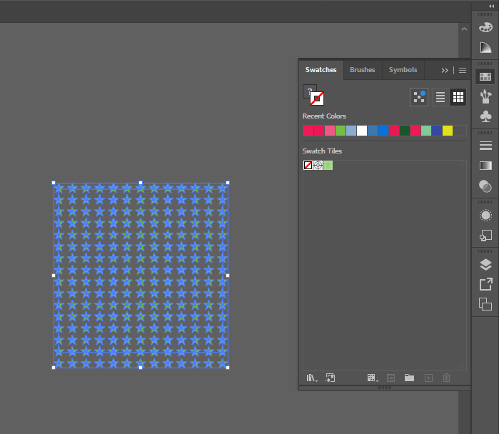
Open Project File:

Select Group selection tool
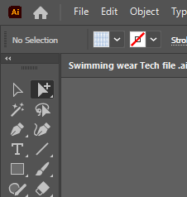

  - Select Garment shape by group selection tool
  - And apply swatches color as fill color
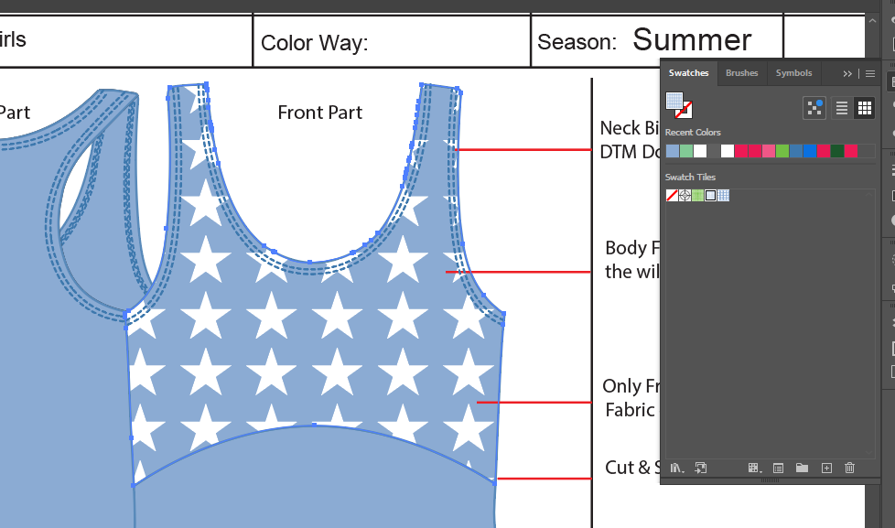

Thanks
You are Successfully Done

Follow Us
(14) Facebook
https://www.youtube.com/@Poran-A
Sell your designs on Shutterstock. Create account with this link
https://submit.shutterstock.com/?rid=185717772&language=en



Road-03, House-54, Lift-03
Sector-12, Uttara, Dhaka

